Writing successful RTL descriptions in verilog

RTL SYNTHESIZABLE VERILOG ELEMENTS (Verilog Design in the Real World)

Verilog was designed as a simulation language and many of its elements do not translate to hardware.

Constructs not supported in synthesis.
Any code that contains the above constructs are not synthesizable, but within synthesizable constructs, bad coding could cause synthesis issues.

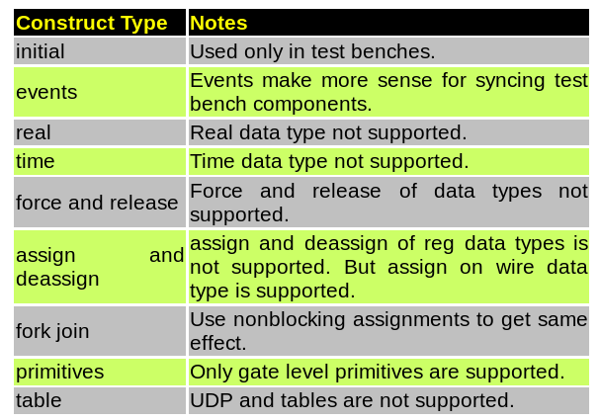

Verilog is such a simple language; you could easily write code which is easy to understand and easy to map to gates. Code which uses if, case statements is simple and cause little headaches with synthesis tools. But if you like fancy coding and like to have some trouble, ok don't be scared, you could use them after you get some experience with Verilog. Its great fun to use high level constructs, saves time.
The most common way to model any logic is to use either assign statements or always blocks. An assign statement can be used for modeling only combinational logic and always can be used for modeling both combinational and sequential logic.

https://fr.slideshare.net/vintrainvlsitraining/coding-style-for-good-synthesis

https://ocw.mit.edu/courses/electrical-engineering-and-computer-science/6-884-complex-digital-systems-spring-2005/lecture-notes/

https://ocw.mit.edu/courses/electrical-engineering-and-computer-science/6-884-complex-digital-systems-spring-2005/lecture-notes/l06_clocks.pdf



